### LONDON’S GLOBAL UNIVERSITY

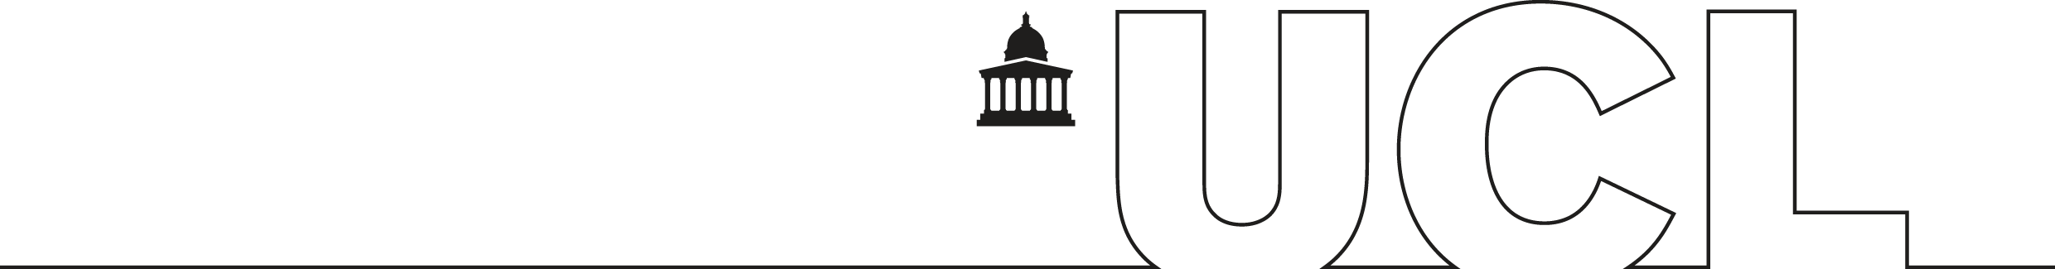

# Minutes for Team meeting 20/11

Date: 20/11

Time: 18:30 -19:00

Duration: 30 minutes

Location: microsoft teams

**Meeting Purpose**

The meeting purpose was to achieve the following:

1. Discuss the 2 different implementation approaches
2. Decide on an implementation
3. Split the first week work

**Attendance**

|  |  |
| --- | --- |
| Meeting Facilitator | Dimitrios Bouras |
| Meeting Secretary | Tomas Kopunec |
| Present | Saleh Mohamed, Gudmundsdottir Telma, Wang Yi-Yu, Wang Derek, Lou Jiafan, Lu Jiashun, |
| Absence and apologies |  |

**Meeting Agenda**

|  |  |  |  |  |
| --- | --- | --- | --- | --- |
|  | **Activity/Topic/Item** | **Time spent** | **Discussion leader** | **Actions** |
| 1. | *We have decided to create a tool with a simple UI that helps users easily input their parameters. The tool will then generate the YAML file for them, trigger the IEF, and collect the results. It will present the results in an easy-to-read manner. This way, users will be more likely to use the IEF since it will be easier and simpler. Additionally, they will have the ability to toggle with the input parameters and perform tests to find the best scenario to optimize, e.g., low carbon compute.* | 20 minutes | Bouras | *new meeting to inform company* |
| 2. | Split the work:  Jiashun, Yi-Yu :stakeholders  Tomas :context  Telma, Mohamed :architectural concerns  Jiafan, Derek :goals | 10 minutes | Bouras | github issue created for each task |
| 3. |  |  |  |  |
| 4. |  |  |  |  |
| 5. |  |  |  |  |
| 6. |  |  |  |  |

**Actions**

|  |  |  |  |  |
| --- | --- | --- | --- | --- |
| **Action ID** | **Directly Responsible Individual** | **Collaborators** | **Description** | **Deadline**  (and who will check it) |
| **4** | **Jiashun, Yi-Yu** | **Jiafan , Derek** | try to identify all the stakeholder that could be interested in a simulation - tetsing lab tool that invokes the ief identify all the stakeholder that | **Bouras,22/11** |
| **5** | **Tomas** |  | identify the context of the project | **Bouras,22/11** |
| **7** | **Telma, Mohamed** |  | identify the architectural concerns of the project | **Bouras,22/11** |
| **6** | **Jiafan , Derek** | **Jiashun, Yi-Yu** | identify the goals of the project | **Bouras,22/11** |
| **8** | **Bouras** |  | Coordinate the goal/stakeholders/context/architectural concerns identification | **Bouras ,22/11** |